Chapter 6, Solution 40.

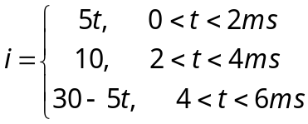

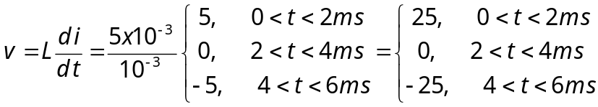

At t = 1ms, v = 25 V
At t = 3ms, v = 0 V
At t = 5ms, v= –25 V

